Груздев В.А. (Полоцкий гос. университет)
http://link.springer.com/article/10.1023/A:1016878131461#page-2

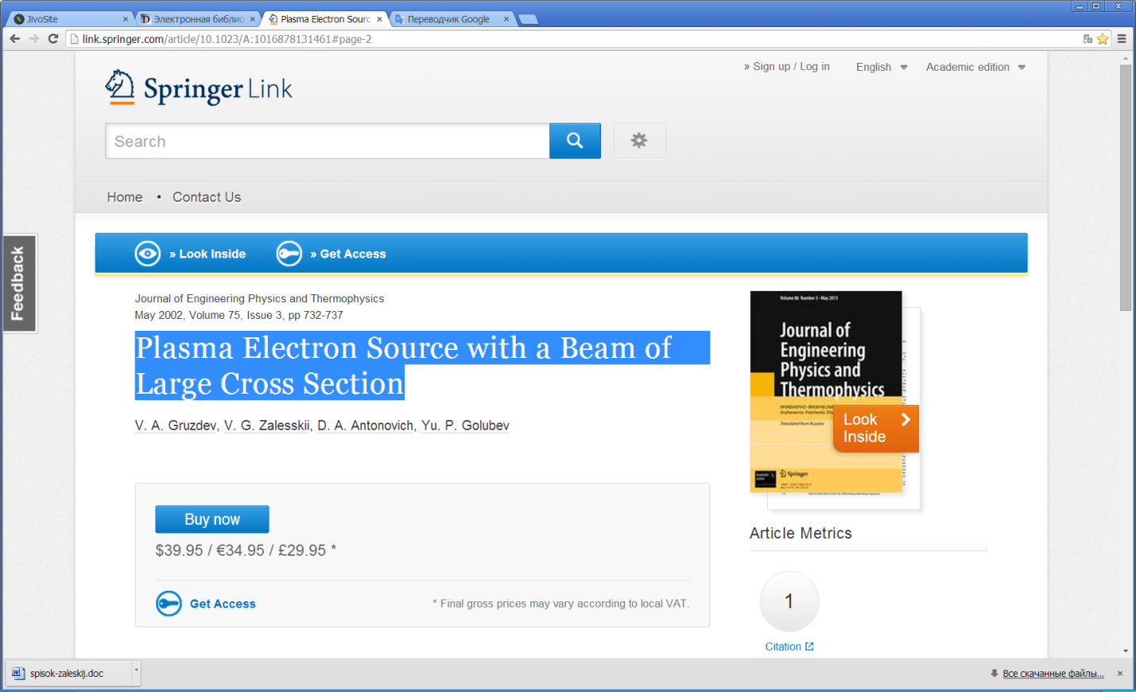

Abstract
We present the design and characteristics of a plasma electron source based on a discharge in crossed E × H fields, which provides the formation of technological high‐energy beams with a large cross section in steady‐state and pulsed regimes, and consider conditions for excitation of a high‐current anomalous glow discharge forming an emitting plasma in a pulsed regime.

