I. Read the dialogues, emphasizing the prominent words.
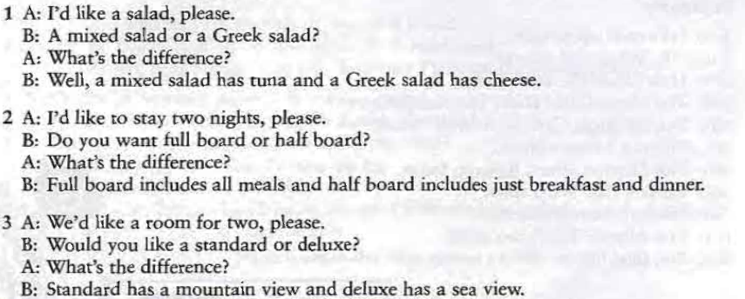
II. Define which word is prominent for context a) and b):
1. I think that's my bag.
a) She's not completely sure that it's her bag. b) Another person is picking up her bag.
2. Is that your phone? a) He can hear an electronic sound from someone's pocket. b) He can see somebody's mobile phone on the seat.
3. Is there a bank in this terminal? a) He is looking for a bank. b) He knows there is a bank in the other terminal but not if there is one in this terminal.
4. I'll have a mixed salad, please. a) Would you like a starter? b) What kind of salad would you like?
5. We're closing now, sorry. a) What time do you close? b) A table for two please.
6. I'd like red wine, please. a) Would you like anything to drink? b) Would you like red or white?

III. Explain the difference in meaning of the given sentences. Note that the prominent words are underlined.
1. a) Do you want the hamburger with chips, or salad? b) Do you want the hamburger with chips or salad?
2. a) Would you like chicken with vegetables, or Russian salad? b) Would you like chicken with vegetables or Russian salad?

IV. Find prominent and non-prominent words in the following sentences and explain their non-prominence:
1. He can't go to the theatre with us, he's got an essay to write.
2. Can you give me a lift? - But you know I can't drive.
3. What's that book you read?
4. I must get my hair cut.
5. When does your train leave? - About an hour from now.
6. Do you think Manchester will beat Barcelona? - No idea. I'm not interested in football.
7. The supermarket should be finished a month from now.
8. I could only see the end of the queue, but in fact there were lots of people waiting.
9. He talked to me about Helen as if I knew her well, although I've never met his wife.
10. She got the job without even an interview or anything.
11. We just relaxed, walked around, sat on the beach and that sort of thing.
12. Did you buy a lot of stuff? - No, just a few presents and things.
13. What's this thing for?
14. They lost our luggage at the airport — it was put on the wrong plane or something like that.

